
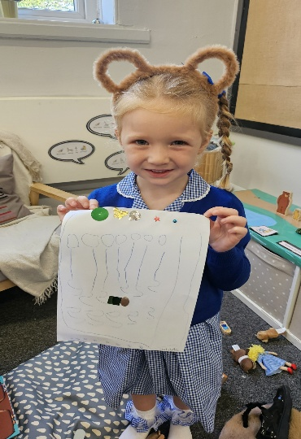

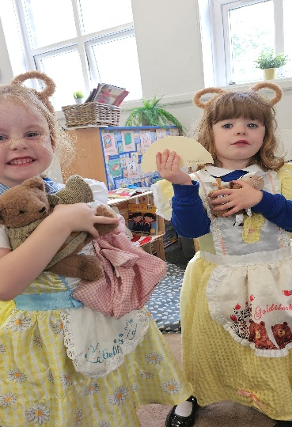
British Values

Why do we vote?

Keeping Our School Community Healthy



As we head into the colder months, it’s common for children to experience coughs and colds. These can sometimes lead to vomiting, usually due to congestion or irritation, and are not typically contagious in the same way as sickness bugs.

Sickness bugs, however, such as those causing vomiting or diarrhoea, are highly infectious and can spread quickly among children. It’s important to be aware of this distinction so we can work together to keep our school community as healthy as possible.

If you're ever unsure whether your child should attend school, please reach out — we’re always here to offer support and guidance. A happy, healthy school is our top priority.
In the spotlight this week…
EYFS
What a fantastic start to the school year we’ve had! The children have all settled into their new routines so beautifully. They are already making new friends, learning to share toys and take turns with each other.
This week, we’ve had lots of fun role-playing the story of Goldilocks and the Three Bears. We have been talking about sizes – big, medium, and small – and using these words in our play.
In maths, the children have been busy matching and sorting objects. In phonics, we’ve started learning the letter sounds: m, a, s, d, and t. The children are already spotting these letters around the classroom. We’ve also been playing lots of fun Fred Games as part of our Read Write Inc. sessions, helping the children to blend sounds together and get ready for reading.

Hoyland Sports Partnership

Well done to our mixed 5/6 football team today, as always great ambassadors for our school.


This week

After our first full week back in school, I’ve been absolutely delighted with how hard the children have been working. It’s been wonderful to see their enthusiasm and focus as they settle into new routines and embrace the exciting learning ahead.

This week, children have started new schemes in both reading and maths, and it’s been fantastic to hear how much they’re enjoying the fresh challenges and opportunities these bring.

Thank you for your continued support — have a great weekend!

Dates for the diary


Monday 8th September
Year 6 Swimming lessons (please remember
your towel and swim costume/shorts)
Celebration Assembly in church
(parents/carers of children receiving awards
are invited to attend from 2:45pm)
Monday 15th September
Year 6 Swimming lessons (please remember
your towel and swim costume/shorts)
Celebration Assembly in church
(parents/carers of children receiving awards
are invited to attend from 2:45pm)
Thursday 18th September
Meet the Teacher 3:45pm – 4:15pm
(Parents/carers invited to come into classes
to meet their child’s teacher)
Friday 19th September
Year 6 visit to The Coal Mining Museum
Monday 22nd September
Year 6 Swimming lessons (please remember
your towel and swim costume/shorts)
Celebration Assembly in church
(parents/carers of children receiving awards
are invited to attend from 2:45pm)
Thursday 25th September
Year 5 visit to The Jorvik Centre
Monday 29th September
Year 6 Swimming lessons (please remember
your towel and swim costume/shorts)
Celebration Assembly in church
(parents/carers of children receiving awards
are invited to attend from 2:45pm)

Attendance Matters
Top Attendance Awarded to:
Y2 (99.3%)
Whole School Attendance
This week: 97.6%
This year: %
Attendance target: 96%

Excellent Attendance This Week!

We’re delighted to share that attendance across school has been excellent this week. It’s wonderful to see so many children in school, ready to learn and engage with all the exciting activities taking place. Thank you to our families for your continued support in helping us maintain a happy, healthy learning environment.

Elsecar Holy Trinity is a nurturing, inclusive, Church school where everyone is valued as a child of God.
We warmly welcome people of all faiths/worldviews and backgrounds, fostering respect, compassion and forgiveness. Rooted in faith, family and community, we aim to grow together in love, developing wisdom, knowledge and aspirations for a brighter future.

01226 743008
s.silverwood@smat.org.uk
Elsecar Holy Trinity Primary School
Church Street, Elsecar, S74 8HS
Our School Our Church Our Community

